Top_song_analysis.R

Apurva Sarode

2020-04-16

fa <- principal(props, nfactors=2, rotate="varimax")  
fa

## Principal Components Analysis  
## Call: principal(r = props, nfactors = 2, rotate = "varimax")  
## Standardized loadings (pattern matrix) based upon correlation matrix  
## RC1 RC2 h2 u2 com  
## Energy 0.91 0.13 0.85 0.15 1.0  
## Dancebility 0.01 0.91 0.83 0.17 1.0  
## Loudness 0.82 0.09 0.68 0.32 1.0  
## Valence 0.33 0.77 0.71 0.29 1.3  
## Acoustiveness -0.70 -0.21 0.54 0.46 1.2  
##   
## RC1 RC2  
## SS loadings 2.10 1.50  
## Proportion Var 0.42 0.30  
## Cumulative Var 0.42 0.72  
## Proportion Explained 0.58 0.42  
## Cumulative Proportion 0.58 1.00  
##   
## Mean item complexity = 1.1  
## Test of the hypothesis that 2 components are sufficient.  
##   
## The root mean square of the residuals (RMSR) is 0.12   
## with the empirical chi square 176.13 with prob < 3.4e-40   
##   
## Fit based upon off diagonal values = 0.91

fa$loadings

##   
## Loadings:  
## RC1 RC2   
## Energy 0.910 0.128  
## Dancebility 0.912  
## Loudness 0.822   
## Valence 0.327 0.775  
## Acoustiveness -0.701 -0.214  
##   
## RC1 RC2  
## SS loadings 2.104 1.502  
## Proportion Var 0.421 0.300  
## Cumulative Var 0.421 0.721

fa$communality

## Energy Dancebility Loudness Valence Acoustiveness   
## 0.8450906 0.8315526 0.6838711 0.7074491 0.5377659

fa$scores

## RC1 RC2  
## [1,] 0.812151678 0.5414312149  
## [2,] 0.468570126 0.6327361872  
## [3,] 0.903879369 0.7796230617  
## [4,] 1.154067089 0.4812714264  
## [5,] 0.709806799 -0.3520772019  
## [6,] 0.609717169 0.3534452561  
## [7,] 0.681932277 1.0808338104  
## [8,] 0.312652499 -0.9734687597  
## [9,] -2.312124974 -1.3844776769  
## [10,] 0.237113538 0.8414572371  
## [11,] 1.069126791 -0.4523503107  
## [12,] 0.219077070 -0.3491795715  
## [13,] 0.217351145 0.7860148973  
## [14,] 0.174147544 1.3499922718  
## [15,] 0.283975418 -0.3959394520  
## [16,] -0.299814156 0.2645732527  
## [17,] 0.155744258 1.0529355485  
## [18,] -0.458477709 0.8194452123  
## [19,] 0.154042001 -0.3869551123  
## [20,] 0.058030475 1.4666878714  
## [21,] -0.580690320 0.6727090125  
## [22,] 0.553538334 -1.2445661460  
## [23,] 0.161111260 0.9256231293  
## [24,] 0.579077777 0.6646903004  
## [25,] 1.070783805 -0.5698569590  
## [26,] 0.696313970 -0.4005358813  
## [27,] 0.942164280 0.4815903409  
## [28,] 1.478948918 0.1937854133  
## [29,] 0.484617078 0.4544224613  
## [30,] 0.522747139 0.3486970966  
## [31,] 0.956125329 0.6664839792  
## [32,] 1.084764336 0.6698279229  
## [33,] 0.943347655 0.2946690205  
## [34,] -0.894946915 -0.2825568989  
## [35,] 0.636024620 -0.7993701768  
## [36,] -0.223577960 1.5065851601  
## [37,] -1.325118479 -2.7574602259  
## [38,] 1.184343936 0.4098993715  
## [39,] 0.552434148 1.0240125913  
## [40,] 0.803429429 -1.4495280434  
## [41,] 0.480015731 -0.4600278958  
## [42,] -1.159620268 -0.3429223500  
## [43,] 1.191207480 -2.6950338727  
## [44,] 0.568580097 1.3440424132  
## [45,] -1.586357888 -2.9893665605  
## [46,] 0.485727414 0.5427514003  
## [47,] 1.226922077 -0.1719080455  
## [48,] 1.215007566 0.1132082490  
## [49,] 0.967643938 -1.0121124865  
## [50,] 0.878460646 0.2235256388  
## [51,] -1.167859469 -1.7253427793  
## [52,] -2.776343385 -0.6302375054  
## [53,] 1.172887592 -0.1663971252  
## [54,] 0.709806799 -0.3520772019  
## [55,] 0.177541208 0.3670100915  
## [56,] 1.054842345 0.7640340843  
## [57,] 0.644556307 0.4803952620  
## [58,] 0.348223976 0.2564905186  
## [59,] -0.897062099 -0.1456942927  
## [60,] 0.382705393 0.8108192947  
## [61,] 1.362163328 0.2393142076  
## [62,] 0.787037729 -0.4677992141  
## [63,] 0.053218135 -0.9936829474  
## [64,] 0.219077070 -0.3491795715  
## [65,] 0.354725078 -1.0702445101  
## [66,] 0.518088244 0.0320270921  
## [67,] 0.531459750 0.6831986641  
## [68,] 0.932319451 0.1564107609  
## [69,] -0.538824514 0.3866351831  
## [70,] -1.202196786 -0.2466172611  
## [71,] 0.268786323 0.4694218982

fa.parallel(props)

## Parallel analysis suggests that the number of factors = 3 and the number of components = 2

fa.plot(fa)

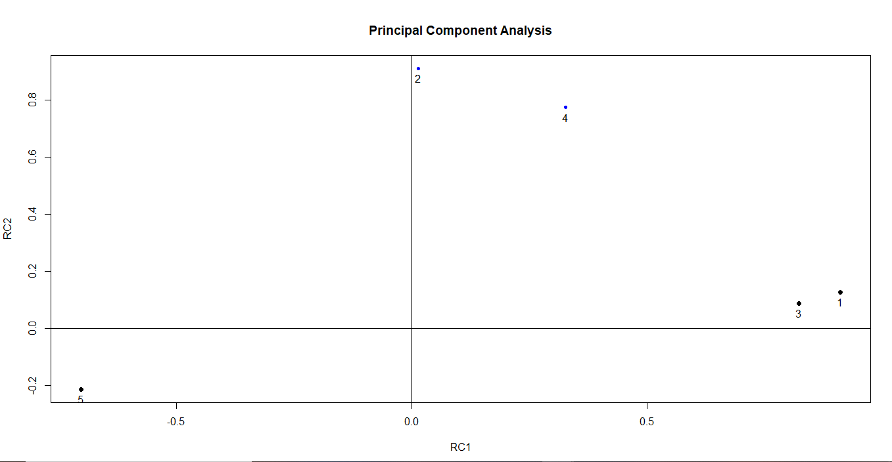

fa.diagram(fa) #Visualization of the factors between relationships

